InsurAI - AI-Powered Insurance Advisor

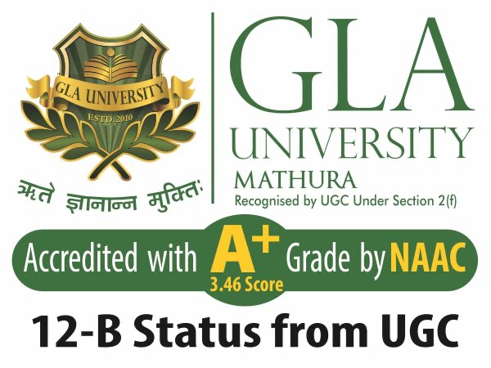

Team Members:

Name: Class & Sec: Univ Roll No.

Harsh Raj(Team Leader) 3AE 2215500073
Hardik Arora 3AC 2215500071
Hemant Prajapati 3AC 2215500078

Project Mentor:
Name: Dr. Ram Manohar Nisarg
Date of Submission: 28th March, 2025.

Abstract:

Overview:
InsurAI is an intelligent, agentic AI-powered insurance advisor that simplifies the process of choosing the best insurance policies. It provides personalized recommendations based on user needs, affordability, and policy details by scraping online insurance data and analyzing uploaded PDFs.

Objective:
The primary goal of InsurAI is to enhance insurance decision-making by leveraging AI-driven insights, improving user experience, and ensuring transparency in insurance policies.

Current Status:
- Successfully implemented PDF parsing to extract policy details.
- Web scraping of insurance provider websites to gather live data.
- AI-driven recommendation model to suggest policies based on user inputs.
Next Steps:
- Enhance UI/UX for better engagement.
- Implement real-time learning to improve recommendation accuracy over time.
- Strengthen the backend for faster and more reliable results.

Table of Contents:
- Title Page

- Executive Summary / Abstract

- Table of Contents

- Introduction

- Project Description & Methodology

- Work Completed (40% Milestone)

- Preliminary Analysis or Findings

- Future Plan / Next 60%

- Conclusion

10. References
Introduction:

Background:
Choosing the right insurance policy can be challenging due to the overwhelming number of options and complex terms. Many people lack the financial literacy to compare policies effectively, leading to suboptimal decisions. InsurAI addresses this problem by providing AI-driven insurance insights in a user-friendly manner.

Project Objectives:
- Develop an AI-powered insurance advisor with personalized recommendations.
- Implement web scraping to extract live data from insurance providers.
- Improve policy transparency by analyzing uploaded insurance PDFs.
- Ensure a visually engaging and intuitive UI.

Initial Project Plan:
The project was initially planned in phases:
- Data collection and scraping
- PDF text extraction
- AI-driven recommendation engine
- UI/UX development
- Testing & deployment

Project Description & Methodology:

Conceptual & Technical Framework:

InsurAI integrates machine learning, NLP, and web scraping techniques to analyze insurance policies and recommend suitable plans.

Methodology:

- Web Scraping: Extracts live data from policy providers.
- PDF Parsing: Uses PyMuPDF to analyze uploaded policy documents.
- AI Model: GPT-based model generates personalized recommendations.
- User Interaction: Implemented in Streamlit for an engaging UI.
- Continuous Learning: Uses user feedback to refine recommendations.

Justification:
- GPT models ensure intelligent responses.
- Web scraping provides real-time insurance data.
- Streamlit enables a visually appealing and interactive UI.

Work Completed (40% Milestone):

Tasks Accomplished:

- ✅ Implemented web scraping for policy data collection.
- ✅ Built a PDF parser for extracting insurance details.
- ✅ Developed an AI-based recommendation engine.
- ✅ Created a prototype UI using Streamlit.

Results or Outputs:

- Successfully extracted and analyzed policy details.
- Generated personalized insurance recommendations.
- Improved UI for better user experience.
- Overcame initial data parsing issues by refining NLP techniques.

Timeline/Progress vs. Plan:
Task | Planned Completion | Actual Completion | ✅ or ⚡
Data Scraping | Week 2 | Week 2 | ✅
PDF Extraction | Week 3 | Week 3 | ✅
AI Model | Week 5 | Week 5 | ✅
UI Development | Week 6 | In Progress | ⚡

Preliminary Analysis or Findings:

Insights Gained:

- Insurance providers structure data differently, requiring dynamic scraping techniques.
- Users prefer simplified summaries rather than lengthy policy documents.

Problem Areas:

- Web scraping inconsistencies due to site structure changes.
- Ensuring AI-generated recommendations align with real-world policies.

Mitigation Strategies:

- Implementing backup data sources for scraping.
- Refining AI models using more policy data and user interactions.

Future Plan:

Remaining Tasks:

- UI enhancements for a more engaging user experience.
- Implementing an interactive chatbot for better assistance.
- Real-time learning model to improve accuracy based on user feedback.
- API integration with major insurance providers.

Refined Timeline:

Task | Estimated Completion
UI/UX Enhancement | Week 8
AI Learning Improvement | Week 10
Final Testing & Debugging | Week 12

Anticipated Results:
- Highly interactive and visually appealing application.
- Enhanced accuracy of recommendations.
- Fully functional AI-driven insurance advisory system.

Conclusion:

Summary:

InsurAI aims to revolutionize how users choose insurance policies by leveraging AI and web scraping techniques. So far, 40% of the project is complete, with a functional prototype in place.

Significance:

This progress is promising as it demonstrates the feasibility of AI-driven insurance advisory. The next phase will focus on refining accuracy and UI engagement.

Next Steps Emphasis:

The immediate priority is to enhance the user interface and implement learning-based improvements for better recommendations.

References:

- PolicyBazaar: https://www.policybazaar.com/

- HDFC ERGO Insurance: https://www.hdfcergo.com/

- Max Life Insurance: https://www.maxlifeinsurance.com/

- PyMuPDF Documentation:
https://pymupdf.readthedocs.io/en/latest/

- OpenAI GPT-4: https://openai.com

